Project Design Phase-II

Solution Requirements (Functional & Non-functional)

Date | 1 Feb 2026
Team ID | LTVIP2026TMIDS24920
Project Name | Strategic Product Placement Analysis: Unveiling Sales Impact with Tableau Visualization
Marks | 2 Marks

Functional Requirements:
Following are the functional requirements of the proposed solution.

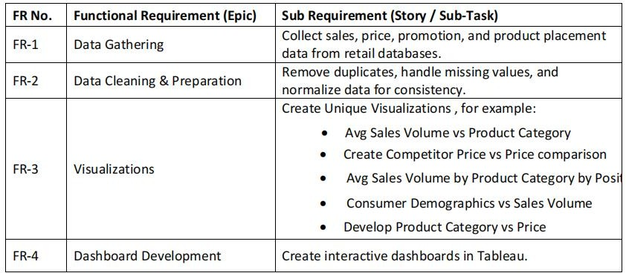

Non-functional Requirements:
Following are the non-functional requirements of the proposed solution.

NFR  No. | Non-Functional  Requirement | Description
NFR-1 | Usability | User-friendly UI with simple navigation and responsive design using Bootstrap and Material UI libraries.
NFR-2 | Security | Secure handling of user data, ensuring integrity and  security of every transaction and user-contributed content.
NFR-3 | Reliability | Consistent functionality and stable performance under  varying user loads and interactions.
NFR-4 | Performance | Fast response times for Browse projects, submitting bids, communicating, and loading dashboards, facilitated by  Express.js and MongoDB.
NFR-5 | Availability | The platform should aim for high uptime to be the go-to  platform for users seeking opportunities.
NFR-6 | Scalability | The client-server model with Express.js backend  .MongoDB data storage offers a scalable solution for future growth.

